Brainstorm & Idea Prioritization Template Ideation Phase
Date | 21 September 2026
Team ID | SWTID-2026-8948
Project Name | AI FAQ Assistant
Maximum Marks | 4 Marks

Brainstorming and Ideation Phase
The brainstorming and ideation phase was conducted to identify a suitable problem and develop possible solutions for managing frequently asked questions efficiently. The team discussed common problems faced by users and organizations in handling repetitive questions, FAQ creation, information searching, and providing quick responses.
Step-1: Team Gathering, Collaboration and Select the Problem Statement
The team members gathered and discussed various problems that could be addressed through a software-based solution. Different ideas related to FAQ management, information searching, automated responses, and user support were discussed.
After discussion, the following problem statement was selected:
Problem Statement:
“Organizations and support teams often receive repetitive questions, making manual FAQ creation, management, searching, and providing quick answers time-consuming.”
The team decided to develop an AI FAQ Assistant that provides a centralized platform for FAQ management and AI-powered question answering.
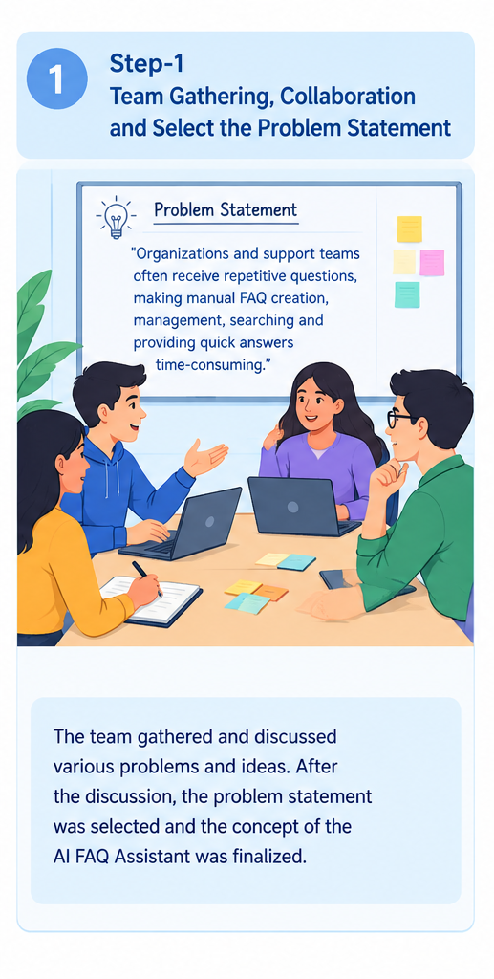
Step-2: Brainstorm, Idea Listing and Grouping
The team generated and discussed different ideas that could be included in the proposed system. The ideas were grouped based on their functionality.
Brainstormed Ideas
- User registration and login
- Secure user authentication
- FAQ creation and management
- FAQ categorization
- FAQ search
- AI-generated questions and answers
- AI-powered question answering
- Semantic search
- FAQ update and deletion
- Secure password storage
- Database management
- Error handling
- Schema validation
- REST API implementation
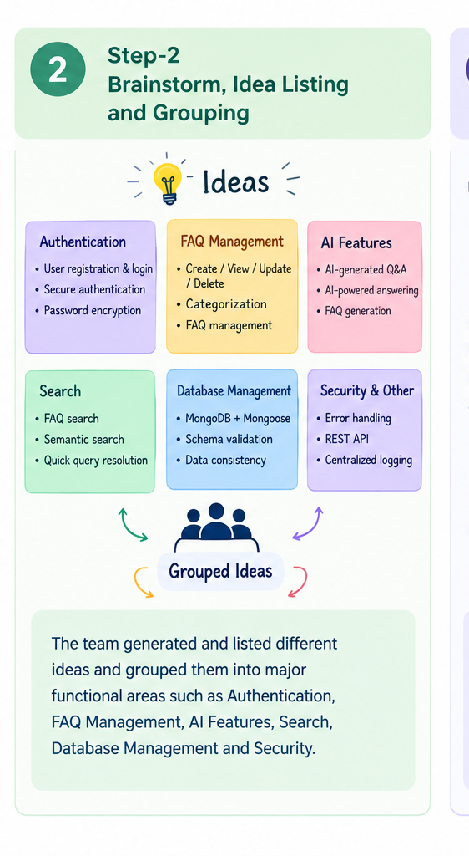
These ideas were grouped into major functional areas such as Authentication, FAQ Management, AI Features, Search, Database Management, and Security.

Step-3: Idea Prioritization
The identified ideas were reviewed and prioritized based on their relevance to the project objectives, usefulness to users, and feasibility of implementation.
High-Priority Ideas
- User authentication
- FAQ creation, viewing, updating, and deletion
- AI-powered question answering
- AI FAQ generation
- FAQ search
- Database management
Supporting Ideas
- Category management
- Semantic search
- Password encryption
- Schema validation
- Centralized error handling
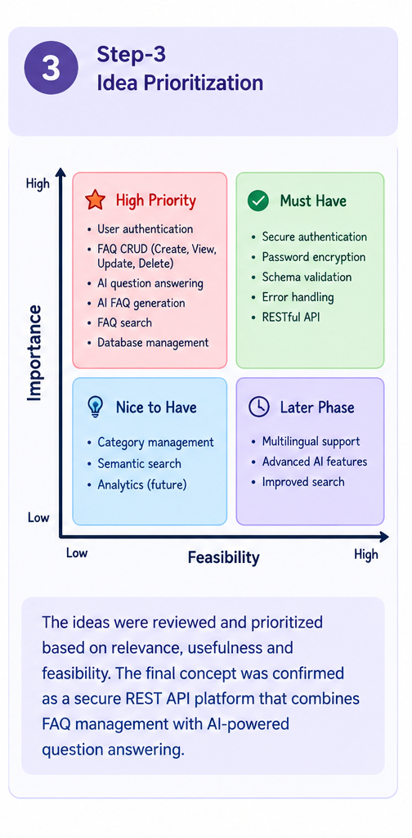
- RESTful API structure
Based on the brainstorming and prioritization process, the team finalized the concept of developing the AI FAQ Assistant, a secure REST API platform that combines FAQ management with AI-powered question answering.

